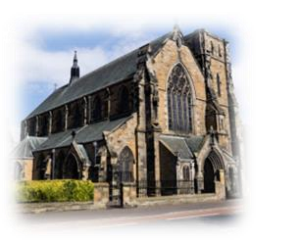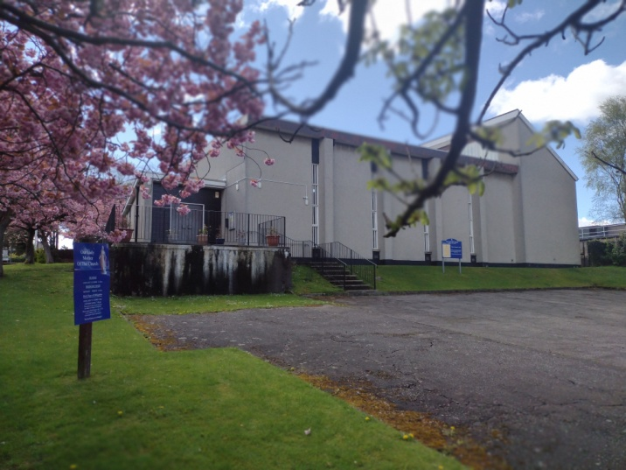

ST CUTHBERT’S CHURCH & OUR LADY   
MOTHER OF THE CHURCH.   
Archdiocese of St Andrews & Edinburgh   
  
**Parish Priest: Fr. Francis C. Ututo, SMMM**

***St. Cuthbert’s Church*** *104, Slateford Road, EH14 1PT*

***Our Lady Mother of the Church*** *1 Curriehill Road, EH14 5NS*

**Parish email:** [staned@stcuthbertschurch.com**.**](mailto:staned@stcuthbertschurch.com) |**Parish No**: 0131 443 1317] **For Parish Hall Hire, Call:** 077 1195 3146   
**Website**: [www.stcuthbertschurch.com**.**](http://www.stcuthbertschurch.com.) |**Twitter, Instagram, TikTok**: @St. CuthbertsandOurladys  
**Office Timings**: Tue: 11.00 am - 2.00 pm |Thurs: 11.00 am - 2.00 pm | Fri. 3.00 pm - 5.00 pm

***Weekend of 28/29 December, 2024 YEAR A***

|  |  |  |  |  |
| --- | --- | --- | --- | --- |
| ***SUNDAY OF THE HOLY FAMILY OF JESUS, MARY AND JOSEPH.***  ***1st Reading*:** Book of Sirach. 3:2-6,12-14  ***Response to the Psalm****: Blessed are all who fear the Lord, and walk in his ways.*  ***2nd Reading****: A reading from the letter of St Paul to the Colossians. 3:12-17*  ***Gospel Acclamation****:* ***Alleluia, Alleluia!***  *Let the peace of Christ rule in your hearts; let the word of Christ dwell in you richly.* ***Alleluia!***  ***Gospel:*** *Matthew 2:13-15.*        ***Gospel: John 20.1-9***  ***Gospel:*** |  |  | ***WEEKEND MASS TIMES***  ***Saturday Vigil Mass St Cuthbert’s: 6.00pm***  ***Sunday Morning Masses***  ***St. Cuthbert’s: 9.30 am***  ***Our Lady’s Curriehill:***  ***11.30 am*** | *hand maid of the lord.jpg* |

|  |
| --- |
| **Dear Friends** Today, we celebrate the feast of the Holy Family of Jesus, Mary and Joseph. This brings to our attention that the most elementary Christian communities of our lives is the family into which we are born. The purpose of this is to promote the sacredness of every family. Parents have the responsibility to teach and train their children well and Children have the duty to listen, respect and cherish the family values that are in line with the divine commandments. So let us all go back home today and ask ourselves, what have our individual families become? Are they like the family of JESUS< MARY & JOSEPH? |

**COMMUNION ANTIPHON**: ***Our God has appeared on the earth and lived among us.***

**PARISH UPDATES**: **Fr Francis is away** for about four weeks for his annual holidays from the 31st of December. Kindly keep him in your prayers. Fr Peter Kelly will be celebrating our weekend’s masses in these times. In the case of an emergency kindly call Mary Mulligan or Jeanette O’Rourke for matters concerning St Cuthbert’s; while you can Call Val Lawrie on matters that concerns Our Lady’s.

**Catechism Class**. We wish to invite and encourage candidates who are due to receive the sacrament of confirmation to please submit their consent forms as we shall begin classes on the 1st of February 2025.

**Diploma in Catechetic**. Take the Diploma in Catechetic and make the Holy Year 2025 a time of discovery in your life of faith. The course is run by the Archdiocese and starts in January. It consists of a weekly lecture on Zoom, guided reading from the Catechism and regular 1-to-1 support to mark the Holy Year. The course is being offered at £125 (normally £200). Find out more and register at [bit.ly/diploma2025](https://www.eventbrite.co.uk/e/diploma-in-catechetics-2025-registration-1033719872967?aff=oddtdtcreator" \t "_blank" \o "https://www.eventbrite.co.uk/e/diploma-in-catechetics-2025-registration-1033719872967?aff=oddtdtcreator)

|  |  |
| --- | --- |
| ***St. Cuthbert’s Offertory Collections.***  ***Last Sunday’s collection: 21/22 December 2024: £788*.35**  **Special Collection for SMMM Seminarians: £484.00** | **Our Lady’s Offertory Collections. *Last Sunday’s collection: 21/22 December 2024: £246.70* Special Collection for SMMM Seminarians: £290.78** |

|  |  |  |  |  |  |  |  |  |  |  |  |  |  |  |  |  |  |  |  |  |  |  |  |  |  |  |  |  |  |
| --- | --- | --- | --- | --- | --- | --- | --- | --- | --- | --- | --- | --- | --- | --- | --- | --- | --- | --- | --- | --- | --- | --- | --- | --- | --- | --- | --- | --- | --- |
| |  |  |  | | --- | --- | --- | | **ST CUTHBERT’S, SLATEFORD** | | | | **MASS TIMINGS** | **MASS INTENTIONS** | **MASS DONOR** | | **Saturday** **Vigil Mass** 6.pm |  |  | | **Sunday** 29 December 9.30 am |  |  | | **Mass Bookings.** We are reminded that the booking of mass for our special intentions, wedding anniversaries, Birthday thanksgiving, Death anniversaries of our loved ones and general prayers is highly recommended. The mass stipends (Donations) are part of our contribution towards the good of the church and support of our priest.  **We have created a new page on the parish website called “News & Events”** and we will update this regularly with items from the newsletter and other items of interest.  You will also be able to download the newsletter. To view the page simply log on to [stcuthbertschurch.com](http://stcuthbertschurch.com/) and click on ”News & Events”.  Why not check regularly to stay up to date with what is going on in the parish and the wider Archdiocese.  **Church Heaters**. Thank you to all our dear parishioners who have donated towards the new Church heating system. We are grateful and we encourage us all to be part of this. God bless us all.  **St Cuthbert’s 200 club winning numbers for November 2024.** Congratulations to the winning numbers for the month of November. The following are the winning numbers:  **16, 102 and 172.**  **Sunday Morning Tea & Coffee**. The Parish Sunday mornings Tea & coffee will be on break this weekend and will resumes on the 5th of January 2025. | | | |  | |  |  |  | | --- | --- | --- | | **OUR LADY MOTHER OF THE CHURCH, CURRIE** | | | | **MASS TIMINGS** | **MASS INTENTIONS** | **MASS DONOR** | | **Sunday** 29 December 11.30am |  |  | | **Mass Bookings.** We are reminded that the booking of mass for our special intentions, wedding anniversaries, Birthday thanksgiving, Death anniversaries of our loved ones and general prayers is highly recommended. The mass stipends (Donations) are part of our contribution towards the good of the church and support of our priest.  **Sacristan**. We wish to thank Jim Vasey once again for taking up the position of the Parish Sacristan. If any parishioner needs to reach out to Jim, you can contact on 07483 256067 0r via [vaseyja@gmail.com](mailto:vaseyja@gmail.com)  We are also looking forward to having more volunteers to assist Jim. Kindly contact Fr Francis if you are interested.  **Ladies Coffee Morning at The Mill, Balerno** Please join us for an 'after Christmas' coffee morning at the Mill on Tuesday, 14th January at 10.30am. If you're interested add your name to the list at the back of the church so we have an idea of numbers. Let Gerry know if you need a lift. 07500 898990. Be there or be square! | | | |

**Blessings to you, your families and those who are dear to you in Jesus’ name, Amen. ~ *Fr Francis***